**Experiment 14**

**Aim:**

Write a program in C language to operate the

LCD

LEDs

7 Segment display

Stepper Motor

**Tool Used:** Keil uVision4

**CODE: LCD**

#include <LPC214x.h>

#define DATA_PORT_SET       IOSET1

#define DATA_PORT_CLR       IOCLR1

#define DATA_DIR            IODIR1

#define D7                  23

#define D6                  22

#define D5                  21

#define D4                  20

#define D3                  19

#define D2                  18

#define D1                  17

#define D0                  16

//Set data port pins

#define DATA_PORT (unsigned long)((1<<D7)|(1<<D6)|(1<<D5)|(1<<D4))|((1<<D3)|(1<<D2)|(1<<D1)|(1<<D0))

#define CTRL_PORT_SET       IOSET1

#define CTRL_PORT_CLR       IOCLR1

#define CTRL_DIR            IODIR1

#define CTRL_RS             24

#define CTRL_EN             25

#include"delay.h"

#include"lcd.h"

int main()

{

 int i;

init_lcd();

   while(1)

   {

    cmd_lcd(0x80);

    string_lcd("adhithan ");

    cmd_lcd(0xc0);

    string_lcd(" ** 602162021 ** ");

        for(i=0;i<5;i++)

        {

        cmd_lcd(0x1C);

        delay_ms(1000);

        }

        for(i=0;i<5;i++)

        {

        cmd_lcd(0x18);

        delay_ms(1000);

        }

   }

}

**OBSERVATION:**

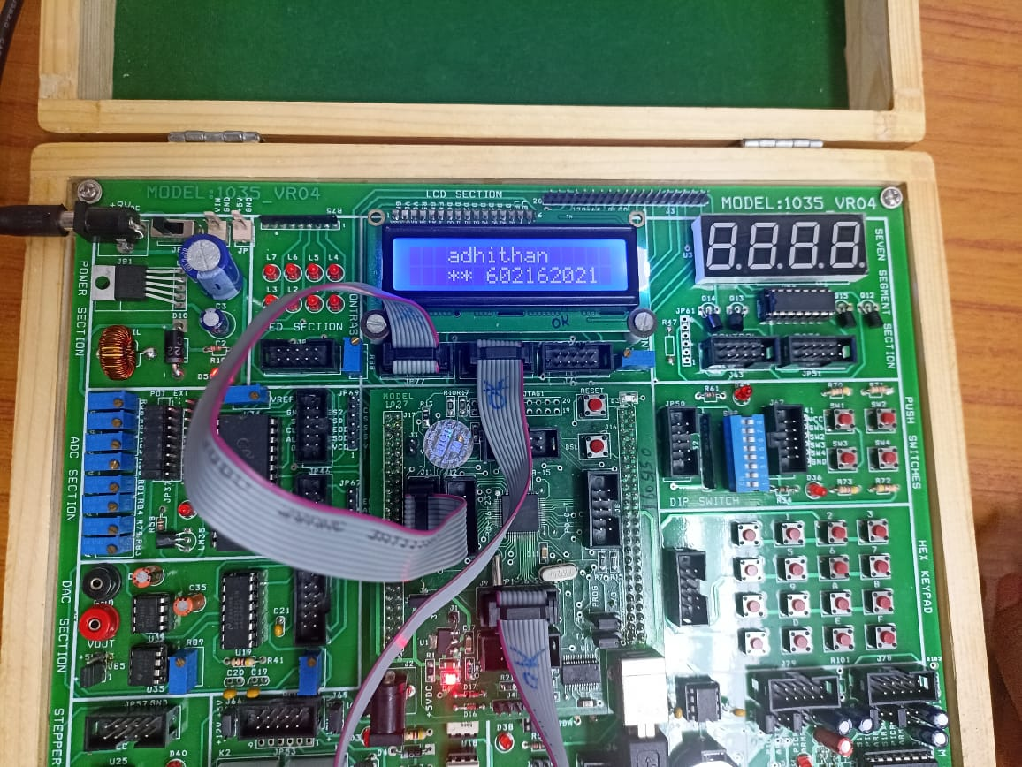

**CODE: LEDs**

#include <LPC214x.h>

#include"delay.h"

#define LED_SET             IOSET1

#define LED_CLR           IOCLR1

#define LED_DIR            IODIR1

#define LED_PIN             IOPIN1

#define LED7                23

#define LED6                         22

#define LED5                21

#define LED4                20

#define LED3                19

#define LED2                18

#define LED1                17

#define LED0                16

//Set data port pins

#define LED_PORT                    (unsigned long)((1<<LED7)|(1<<LED6)|(1<<LED5)|(1<<LED4))|((1<<LED3)|(1<<LED2)|(1<<LED1)|(1<<LED0))

int i,a,b,x,y;

int main()

{

    LED_DIR |= (unsigned long)(LED_PORT);       //initialize D0:D7 pins as output

    LED_CLR |= (unsigned long)(LED_PORT);       //initialize D0:D7 pins as output

    while(1)

    {

    ////////// nibble on off

        LED_CLR |= (0xf0) << LED0;

        LED_SET |= (0x0f) << LED0;

    delay_ms(500);

        LED_CLR |= (0x0f) << LED0;

        LED_SET |=  (0xf0) << LED0;

        delay_ms(500);

    /// odd even on off

        LED_CLR |= (0xff) << LED0;

        LED_SET |= (0xaa) << LED0;

    delay_ms(500);

        LED_CLR |= (0xff) << LED0;

        LED_SET |= (0x55) << LED0;

    delay_ms(500);

    //////// left shift

        LED_PIN = (0x01) << LED0;

    delay_ms(500);

        for(i=0;i<7;i++)

        {

            LED_PIN = LED_PIN << 1;

            delay_ms(500);

    }

    /////////// rotate left

        LED_PIN = (0x01) << LED0;

    delay_ms(500);

        for(i=0;i<7;i++)

        {

            LED_PIN = LED_PIN << 1 | (0x01 << LED0);

            delay_ms(500);

    }

    ////////////    right shift

        LED_PIN = (0x80) << LED0;

        delay_ms(500);

        for(i=0;i<7;i++)

        {

            LED_PIN = (LED_PIN >> 1) & (0X7F << LED0);

            delay_ms(500);

    }

    /////////// rotate right

        LED_PIN = (0x80) << LED0;

    delay_ms(500);

        for(i=0;i<7;i++)

        {

            LED_PIN = (LED_PIN >> 1);

            delay_ms(500);

    }

  }

}

**CODE: 7 Segment Display**

#include"lpc214x.h"

#include"delay.h"

int main()

{

int a,b,c,d,e;

unsigned char arr[] = {0xbf, 0x86, 0xdb, 0xcf, 0xe6, 0xed, 0xfd, 0x87, 0xff, 0xef};

IODIR0 = 0xffffffff;

while(1)

 {

for(a=0;a<=9;a++)

 {

  for(b=0;b<=9;b++)

  {

    for(c=0;c<=9;c++)

    {

      for(d=0;d<=9;d++)

      {

        for(e=0;e<=50;e++)

        {

              IOCLR0 = 0xFFFFFFFF;

              IOSET0 = arr[d]<<16 | 0x0100;

    delay_ms(2);

              IOCLR0 = 0xFFFFFFFF;

              IOSET0 = arr[c]<<16 | 0x0200;

    delay_ms(2);

              IOCLR0 = 0xFFFFFFFF;

              IOSET0 = arr[b]<<16 | 0x0400;

    delay_ms(2);

              IOCLR0 = 0xFFFFFFFF;

              IOSET0 = arr[a]<<16 | 0x0800;

    delay_ms(2);

         }

       }

     }

   }

 }

}

}

**CODE: Stepper Motor**

#include"lpc214x.h"

#include"delay.h"

#define m1                  16

#define m2                  17

#define PORT_SET       IOSET1

#define PORT_CLR       IOCLR1

#define DIR            IODIR1

int main()

{

DIR |= (1<<m1)|(1<<m2);

PORT_CLR = (1<<m1) | (1<<m2);

while(1)

{

        PORT_CLR = (1<<m1) | (1<<m2);

        PORT_SET = (1<<m1);

        delay_ms(4000);

        PORT_CLR = (1<<m1) | (1<<m2);

        delay_ms(1000);

        PORT_CLR = (1<<m1) | (1<<m2);

        PORT_SET = (1<<m2);

        delay_ms(4000);

        PORT_CLR = (1<<m1) | (1<<m2);

        delay_ms(1000);

}

}

**RESULT:**

The C codes Written above have been implemented and verified successfully.